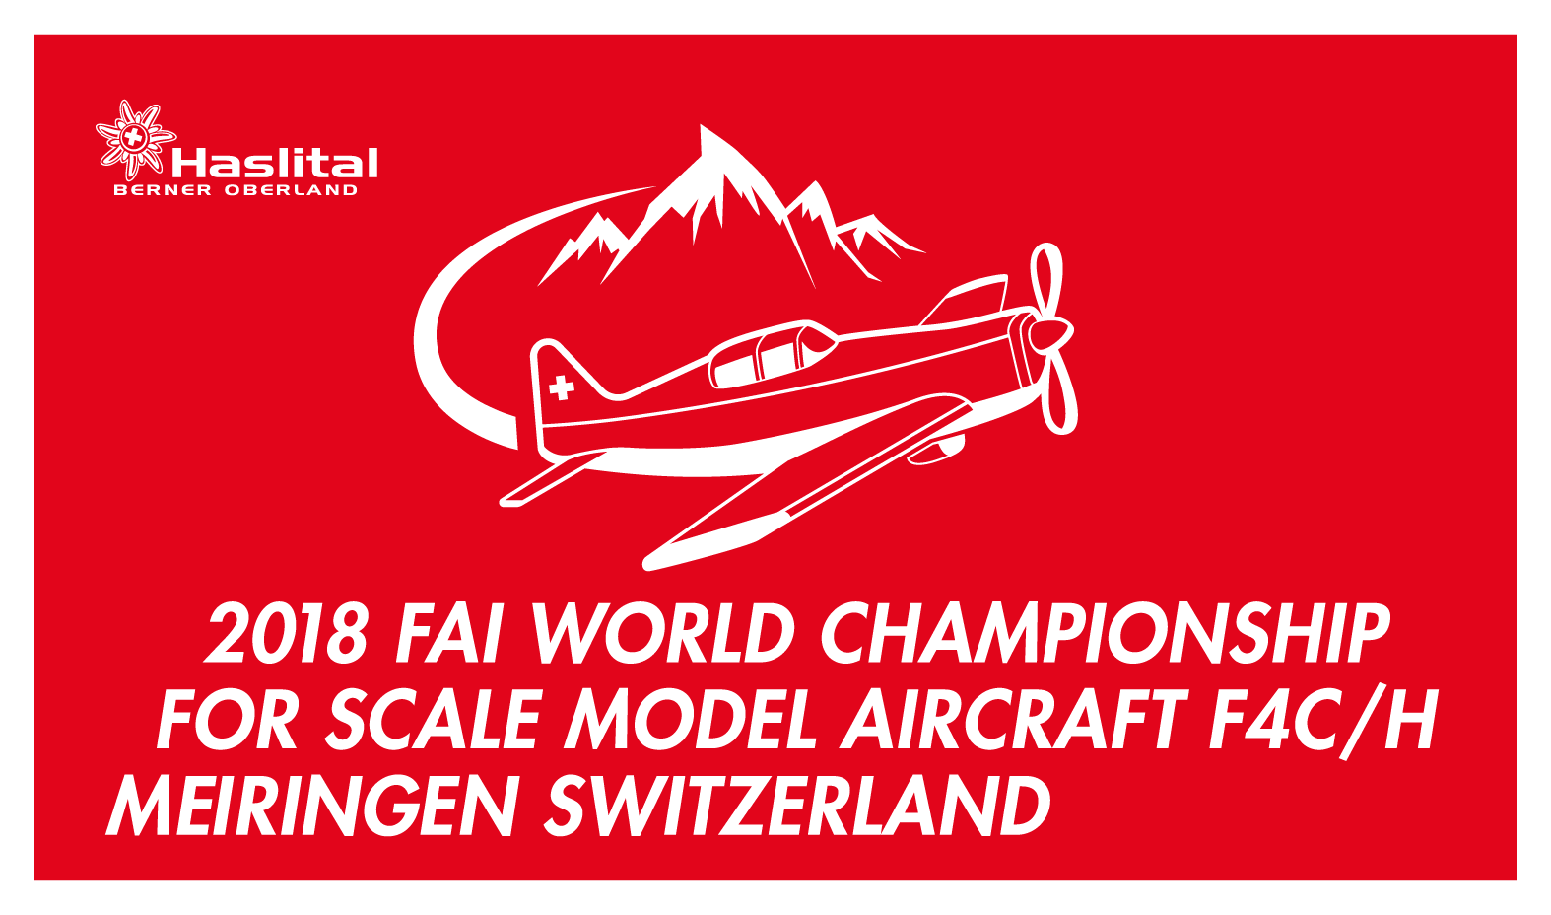
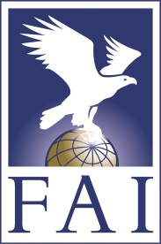

Form #4:

FAI World Championship for Scale Model Aircraft Class F4C/H
July 7 to July 14 2018 Meiringen, Switzerland
www.f4wc2018.com

FAI Anti-Doping Rules & Procedures, Acknowledge and Agreement

(For FAI License Holders)

I, as a member of …………………………………(NAC/Country/Team) and as participant in the 2018 FAI World Championship for Scale Model Aircraft Class F4C/H hereby acknowledge and agree as follows:

1. I have had an opportunity to review the FAI Anti-Doping Rules and Procedures.

2. I consent and agree to comply with and be bound by all of the provisions of the FAI Anti-Doping Rules and Procedures, including but not limited to, all amendments to the Anti-Doping Rules and Procedures and all International Standards incorporated in the Anti-Doping Rules and Procedures.

3. I acknowledge and agree that National Airsport Controls and FAI have jurisdiction to impose sanctions as provided in the FAI Anti-Doping Rules and Procedures.

4. I also acknowledge and agree that any dispute arising out of a decision made pursuant to the FAI Anti-Doping Rules and Procedures, after exhaustion of the process expressly provided for in the FAI Anti-Doping Rules and Procedures, may be appealed exclusively as provided in Article 13 of the FAI Anti-Doping Rules and Procedures to an appellate body for final and binding arbitration, which in the case of International- Level Athletes is the Court of Arbitration of Sport.

5. I acknowledge and agree that the decision of the arbitral appellate body referenced above shall be final and enforceable, and that I will not bring any claim, arbitration, lawsuit or litigation in any other court or tribunal.

6. I have read, and understand this Acknowledgement and Agreement.

Print Name (Last Name, First Name)

Date Signature

