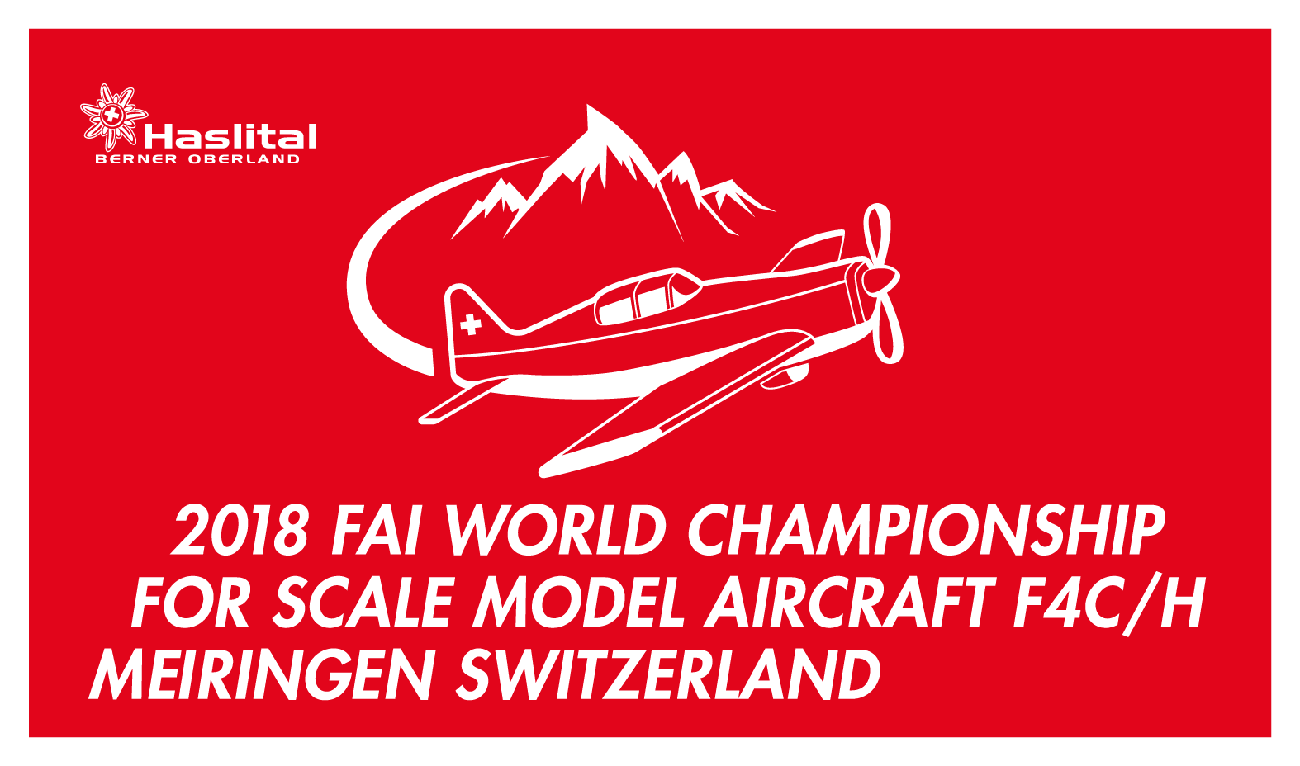
2018 FAI World Championship
for Scale Model Aircraft F4C/H
Yves Burkhardt, Chairman
Aero-Club of Switzerland
Lidostrasse 5
CH-6006 Luzern
Switzerland
e-mail: info@f4wc2018.com

Custom Matters for foreign travellers into Switzerland

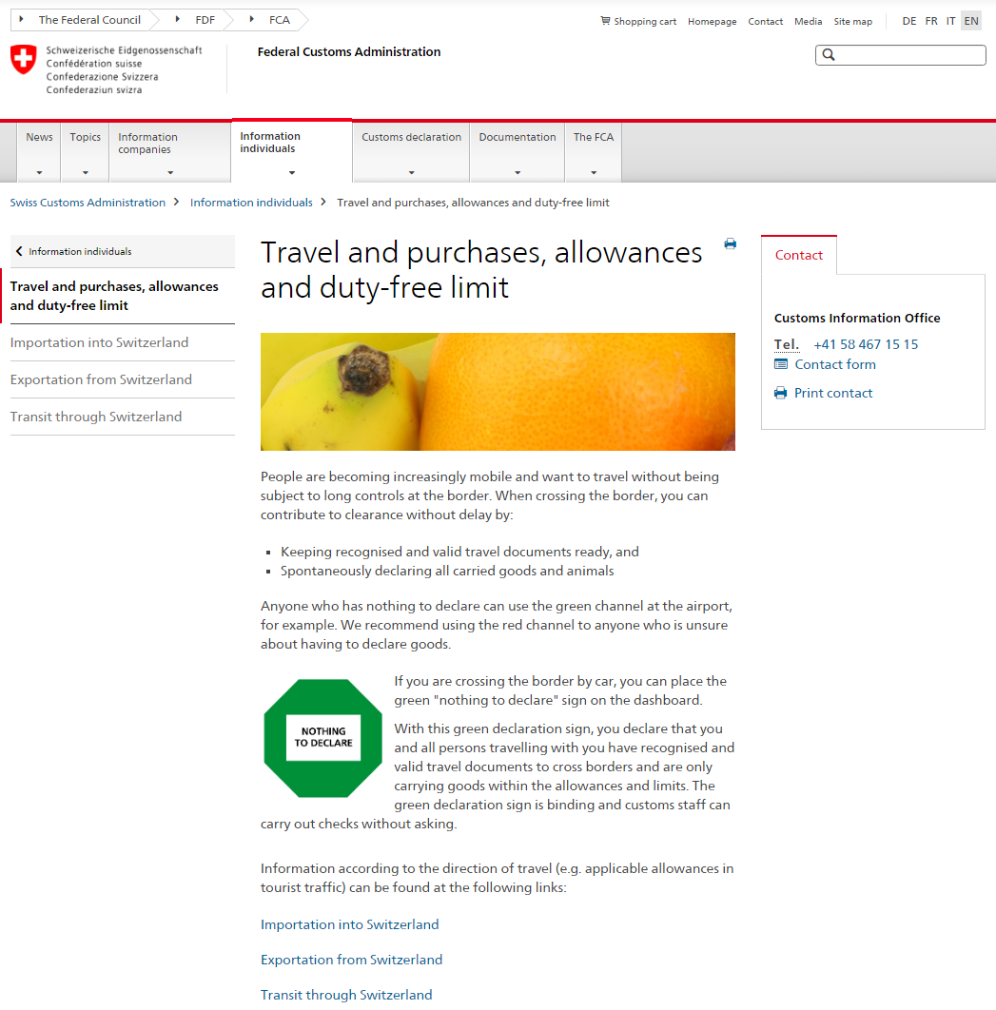

For all custom informations when travelling to Switzerland use the link:

https://www.ezv.admin.ch/ezv/en/home/information-individuals/travel-and-purchases--allowances-and-duty-free-limit.html
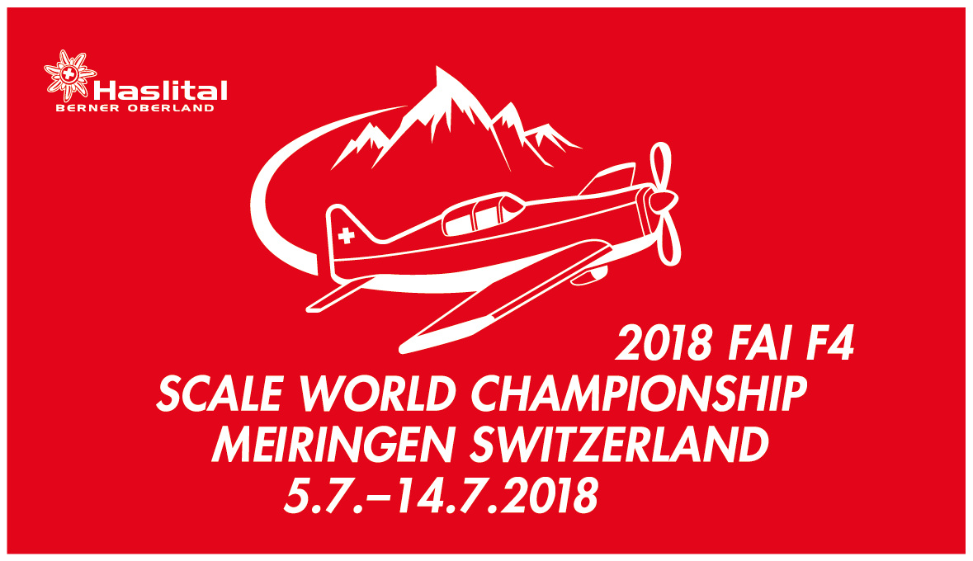
In any case of problems at the custom/boarderline with your modelboxes, please present the following letter at the custom officer:

